
A1

PUBLIC SERVICE OFFICE
P.0 Box 68
Bairiki, Tarawa
Republic of Kiribati
Telephone: + (686) 63030140
www.pso.gov.ki
GOK IN-SERVICE AWARD APPLICATION FORM 2025
(To be completed by Employee/Applicant ONLY)
Application closing date: Friday, 3rd January 2025 at Ministry/SOE.
Ministry/SOE Submission to PSO: Friday, 10th January 2025 before 5:15pm.

PERSONAL INFORMATION (Please type OR print in block letters)
Full Name: (Mr / Ms / Mrs / Miss)

Date of Birth: (dd/mm/yyyy) | Marital Status
Permanent Address: |  | Telephone / Mobile:  E-mail:
Current Position Title:

Category of Award (Please type tick(√)) Public Civil Society Private

PROGRAM DETAILS
Name of Program:
(2024-2026 Approved Priority list)
Priority Number of Program:
(As listed under 2024-2026 Priority List)
Type of Award Applied for:  GoK In-service Award OR Conversion of Private Award to In-Service? | Please tick (√) the appropriate box:  GoK Award Conversion of Private Award
Name of University or Institution

Duration of Course: | Is your program by Research or Coursework? (Please tick (√))  Research  Coursework
QUALIFICATIONS (to be attached)
Have you ever failed a Unit / Course or Program of Tertiary Study? | NO  YES
If YES, have you subsequently passed a similar Unit / Course or Program of Tertiary Study? | YES  NO

DOCUMENTATION CHECKLIST
ALL DOCUMENTS TO BE CERTIFIED BY THE MAGISTRATE COURT
 | YES | NO
Proof of Citizenship
Evidence of Citizenship for the Republic of Kiribati (Birth Certificate (LONG) or Passport).
Proof that you are a PERMANENT employee (or for SOEs implementing Contract Appointment, proof of current/valid contract employment)
- Certified copy of PSC Confirmation Letter for government Ministries and Statutory bodies
- Certified copy of Contract/Confirmation letter for SOEs
Proof that you have been an employee of the Public Sector (continuously) for the past three years.
Certified copy of INITIAL PSC Appointment/PSC Contract Appointment or SRO/CEO confirmation letter for contract appointment/SRO confirmation letter for employment at government project that confirms either of the following:
- 3 years continuous employment either on contract or permanent appointment in a government agency (PSC appointment and SRO confirmation letter required); or
- 3 years in government projects (contract appointment on project position and SRO confirmation letter required); or
- At least 2 years continuous contract service on project (other than government) within Kiribati plus at least 1 year service (either contract/permanent) in a government agency/Ministry (contract appointment on project position and SRO confirmation letter required)
Proof that for the past 3 years any long-term leave/absence (more than a year) was for a private scholarship (academic) which was incomplete/terminated based on reasons of illness, pandemic, donor’s changing policy, changing diplomatic relations or other compassionate grounds (Note – termination due to poor academic performance is not acceptable) – Only if applicable.
- sponsor initial offer letter of private award showing dates or duration of award;
- sponsor letter/notification to the student for termination of the award with reasons (or other written forms of communications to the student outlining reasons for termination);
- transcripts showing course results from start to the end of the award;
- any other relevant supporting information confirming that your private award/scholarship was terminated NOT because of poor academic performance but based on reasons outlined in the criteria above.
All Tertiary Study Records
Certified copies of Transcripts ONLY for academic studies/courses
Proof that you have the level of English and Computer skills required to undertake a tertiary study.
Certified copies of the following:
- If applying for a postgraduate program:
Bachelor Degree Certificate with proof that the program is conducted in English.
- If applying for an undergraduate program:
- English Requirement – Certificates and/or transcripts for IELTS/TOEFL/UU114/TAFE English Course or Test. NOTE - Expired test/course results are deemed invalid.
- Computing Requirement – Transcript for UU100 (Communication & Information Literacy) at USP
- Undergraduate compulsory courses – Transcripts confirming successful completion of UU114 & UU100
Proof that you meet the Age limit (45 years for undergrad applicants & 50 years for postgrad applicants)
Certified copy of Birth Certificate/Passport/National ID Card
Medical Report
Proof that you are physically and mentally fit. Provide a completed and stamped Medical Report Form from the Ministry of Health & Medical Services (MHMS) using the form attached to this application.

NOTE: Additional documents ONLY for applicants who will turn 50 years of age in 2025:
- 2024 SPA or the SRO’s written confirmation on overall performance and suitability for an academic award.
- Written confirmation from employer/SRO on the number of sick leaves taken in 2024 to date.
- Attendance report for 2024 to date or written Confirmation from employer/SRO on overall attendance to work.
Proof that you meet your nominated Institution’s minimum entry requirements
Certified Copy of University Offer letter/Provisional offer for Semester 1, 2025 with the University’s stamp
OR
For cases where you’ve already been provided an offer letter to study your program prior to semester 1, 2024 and the university cannot reissue the same offer (eg. due to its internal procedures/policy etc.) then you are required to provide the initial offer (issued prior semester 1, 2025), your updated transcripts including the University’s confirmation letter (MUST be stamped) which should include the following:
- University confirmation that you’ve already been accepted into the program including the year and semester you were offered;
- You are still active in your program and/or your resumption of studies is accepted for semester 1, 2025;
- The courses you have undertaken/completed and remaining courses required to complete the program and if applicable, also state the courses you enrolled in for semester 2, 2024;
- Any other relevant information.

Applicants for Postgrad Research Proposal (If applicable)
Written proposal of no more than 500 words. It should also include the aim and objectives of the research, its linkage to the existing skill gap and the KV20 as well as how the outcome of the research will contribute to the development of the Kiribati.
ENDORSEMENT

IMMEDIATE SUPERVISOR: | SENIOR RESPONSIBLE OFFICER (SRO):
Fully Name: | Fully Name:
Signature: | Signature:
Date: | Date:

DECLARATION

I certify that:

- The documents that I have provided are true and correct and they represent work done solely by me and no one else.
- I confirm that I have no serious PSC/Board disciplinary action against me from my employment in the Public Sector in the past three years.
- I confirm that I have had no long-term absence from my work place (1 year or greater) for ANY PURPOSE (including study) in the past three years
- I understand that if my declaration is found to be false or misleading it will disqualify me from the scholarship process and I may be liable for further disciplinary action
- If I am successful in my application I will continue with fulltime employment in an Agency within the Public Sector for the bonded period (1.5 multiply the period of the award) after I successfully complete the course of study

Applicant Signature: Date:

A 2
PUBLIC SERVICE OFFICE
P.0 Box 68
Bairiki, Tarawa
Republic of Kiribati
Telephone: + (686) 63030140
www.pso.gov.ki

PRE-SCREENING CHECKLIST FOR GOK IN-SERVICE AWARD 2025
(To be completed by Employer & SRO ONLY)

FULL NAME OF APPLICANT:

AGENCY (Ministry/SOE):
ELIGIBILITY TABLE (Please type V or tick in the YES or NO column for each statement)

NOTE that a “ ” in a shaded box means the applicant is INELIGIBLE. Return the application to the applicant
CRITERIA | YES | NO
(2.2.1) The program must be a priority on the advertised list of Priority Programs for In-Service Academic Awards. (NOTE – Both in-service and pre-service applicable for KANGO/KCCI Only)
Is the Program reflected on the 2024-2026 In service Priority List?
(2.2.2) The applicant must be a citizen of good standing of the Republic of Kiribati.
Is the applicant a Kiribati Citizen?
(2.2.3) The applicant must have been an employee of the Public Sector (continuously) for the past three years.
Has the applicant supplied a certified copy of their INITIAL PSC Appointment/PSC Contract Appointment or SRO confirmation letter for contract appointment/SRO confirmation letter for employment at government project that confirms either of the following?
- 3 years continuous employment either on contract or permanent appointment in a government agency (PSC appointment and SRO confirmation letter required); or
- 3 years in government projects (contract appointment on project position and SRO confirmation letter required); or
- At least 2 years continuous contract service on project (other than government) within Kiribati plus at least 1 year service (either contract/permanent) in a government agency/Ministry (contract appointment on project position and SRO confirmation letter required)

(2.2.4) The applicant must have been working in their Agency for the past three years (starting from the date of application), and not have been on scholarship, long term leave or other long-term absence (1 year or more) from duty during that time.
Has the applicant been at work for the past 3 years, with no absence for 1 year or longer (for any reason?). Exemption is given to those on private scholarship who have not completed their study based on reasons of illness, pandemic, donor’s changing policy, changing diplomatic relations or other compassionate grounds. Termination based on poor academic progress IS NOT ACCEPTABLE.
(2.2.5) The applicant must have had no serious discipline penalty imposed by PSC/Board for the past three years.
Has the applicant received any serious PSC/Board disciplinary sanction in the past 3 years?
Has the applicant supplied certified transcripts for all previous Tertiary Study? (NOTE: letters are not acceptable, records must be official transcripts confirming all results and the final GPA)
(2.2.6) The program applied for must be at a higher level than any current qualification held by the applicant.
Is the program applied for at a higher level than any current qualification held?

(2.2.7) The applicant must demonstrate that they have the level of English and Computer skills required to undertake tertiary study.
- Applicants for postgraduate programs:
Has the applicant successfully completed an undergraduate program conducted in English?
- Applicants for undergraduate programs:
- English Requirement – Has the applicant completed either IELTS/TOEFL/UU114/TAFE English Course or Test? NOTE - Expired test/course results are deemed invalid.
- Computing Requirement – Has the applicant completed UU100 (Communication & Information Literacy) at USP?
- Has the applicant undertaken and successfully complete with pass grades two (2) USP compulsory courses UU114 (English for Academic Purposes) or and UU100 (Communication & Information Literacy)?
(2.2.8) Age limit – 45 years for Undergrad applicants & 50 years for Postgrad applicants
Has the applicant supplied a certified copy of their Birth Certificate/Passport or Citizenship? (Age Limit: 45 years for undergrad applicants and 50 years for postgrad applicants). An applicant should not reach 45 or 50 years of age during application and before undertaking study.
Will the applicant turn 50 in 2025? (If ‘NO’, skip the next Questions (i – iv) and go to 2.2.9). If ‘YES’ answer the questions i – v below:
- Has the applicant produced a complete medical report form (form is attached as part of this application)?
- Has the applicant provided his/her performance appraisal (SPA in 2024) OR the ministry’s confirmation and support that the applicant’s performance is overall satisfactory and suitable/capable for an ACADEMIC award?
- Has the applicant provided a record of no. of sick leaves taken in 2024 to date?
- Has the applicant provided an Attendance Report for 2024 to date or written confirmation from Employer on his/her attendance to work?
Has the applicant provided a Medical Report?
A completed Medical Report Form should be provided submitted as one of the required checklists. Without this form or an incomplete medical report will make this application incomplete.
(2.2.9) The applicant must meet their nominated Institution’s minimum requirements for entry.
Does the applicant produce written proof that they meet their nominated Institution’s minimum entry requirements/ University Offer letter/Provisional offer /Offer of Place with the University’s stamp OR the University’s confirmation letter if an offer has already been issued? (If you can’t tell, tick NO)
(2.2.10) The applicant must not have failed a course/unit or program of Tertiary study. If so, the applicant must have successfully completed or passed the failed program or other tertiary studies/courses/units at the same level of the award/program being applied for.
Has the applicant failed a course/unit/program of tertiary study?
If yes, has the applicant successfully completed or passed a failed program or other tertiary studies/courses/units at the same level of award/program being applied for?
Other requirements:
Has the applicant had a program terminated, either by a sponsor or by the University?
Will the applicant be able to complete the bond (1.5 times the length of the award) following completion of the program?
Is the applicant applying for a postgraduate by research program?
If YES, have they attached a research proposal of no more than 500 words?
IMMEDIATE SUPERVISOR: | SENIOR RESPONSIBLE OFFICER (SRO):
Fully Name: | Fully Name:
Signature: | Signature:
Date: | Date:

A 3
PUBLIC SERVICE OFFICE
P.0 Box 68
Bairiki, Tarawa
Republic of Kiribati
Telephone: + (686) 63030140
www.pso.gov.ki

PERFORMANCE ASSESSMENT FORM FOR GOK IN-SERVICE AWARD 2025
(To be completed by Employer, SRO, and Applicant/Employee)

FULL NAME OF APPLICANT:

AGENCY (Ministry/SOE):

Please give the rating against the categories below by writing the appropriate number in the box. Refer to the rating scale and guideline below for assistance. Please discuss the performance assessment with the Applicant/Employee and let him/her sign the form when both parties AGREED.
 | Attendance | Approach to Work | Leadership | Problem Solving | Report Writing | TOTAL  SCORE
SUPERVISOR
SRO
ADDITIONAL | Research Proposal | Relevance of the Program | TOTAL SCORE
SUPERVISOR
SRO

FULL NAME OF SUPERVISOR:

TITLE OF SUPERVISOR:

SIGNATURE: DATE:
FULL NAME OF SRO:

TITLE OF SRO:

SIGNATURE: DATE:

To be signed by APPLICANT/EMPLOYEE

SIGNATURE: DATE:

ANNEX I - PERFORMANCE ASSESSMENT
GUIDELINE

PERFORMANCE ASSESSMENT
GUIDELINE

Attendance
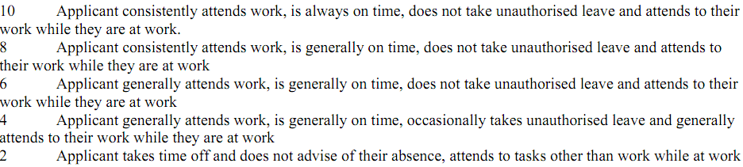
Approach to work
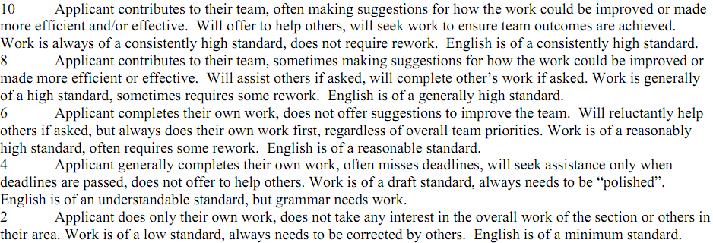
Leadership Potential
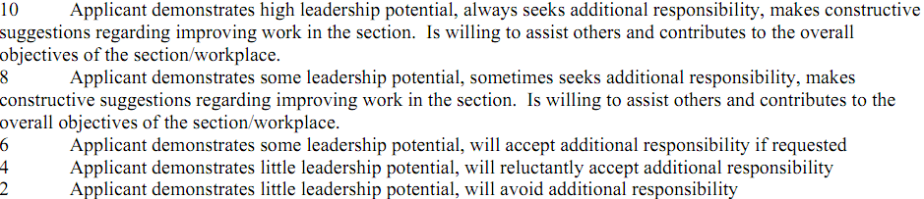
Problem Solving Approach
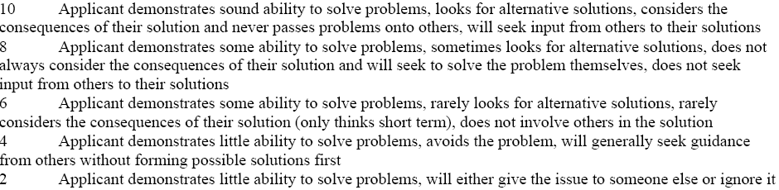

Report Writing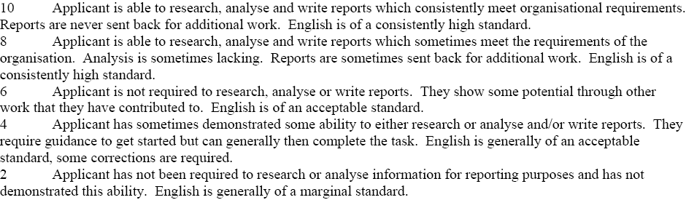

ADDITIONAL

Postgraduate Research Proposal
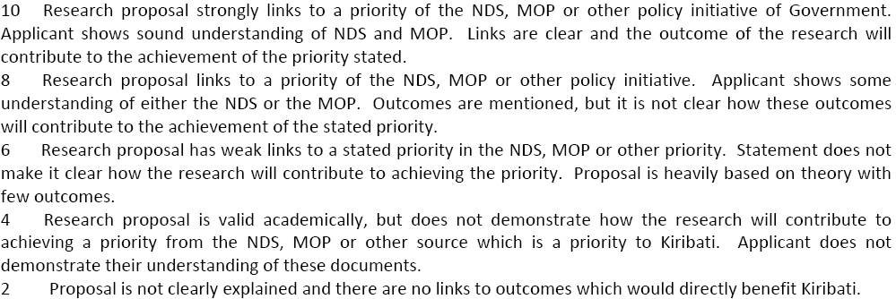
Relevance of the Program
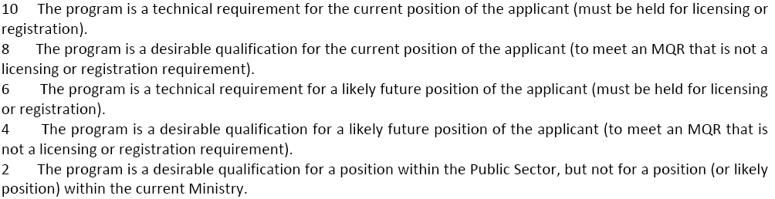

GOK In-service Scholarship Medical Report Form
Name of Applicant:
Age: | Gender: | Height: cm |  | Weight kg
Blood Pressure:

Blood Group: A B AB O Other ( )

Any history of Surgery? |  |  | Has the applicant ever been admitted to the hospital? Yes/No  If yes, how many times? _______  Is it a serious medical condition likely to occur in the future? Yes/No
Is the person free of infectious diseases (AIDS, tuberculosis, trachoma, skin diseases, covid-19, Hepatitis B, etc.)? |  |  | Does the person examined have any condition or defect which might require treatment during the course or affect the person’s ability to learn/study?
List any abnormalities indicated in the chest X ray: |  |  | Does the person examined have any Non-Communicable Disease (NCD) including Hypertension and Diabetes?  Indicate the appropriate level at this stage:  Minor/Mild/Serious
Overall, is the person examined physically and mentally able to carry out academic studies/training away from home? Yes/No
I certify that the applicant is (please circle) overall
- medically fit
- not medically fit
to undertake an Academic study/course Overseas.

Other Comments:
____________________________________________________________________________________________________________________________________________________________________________________________________________________________________________________________________________________________________________________________________________________________________________________

Name of Physician: Dr.___________________________

Address of Clinic/hospital: _________________________

Contact details: i) Telephone - __________________ ii) Email - ______________________

Date: _____________________

Signature of Physician: _______________________ Official Stamp:

